Business Provided Style Guide
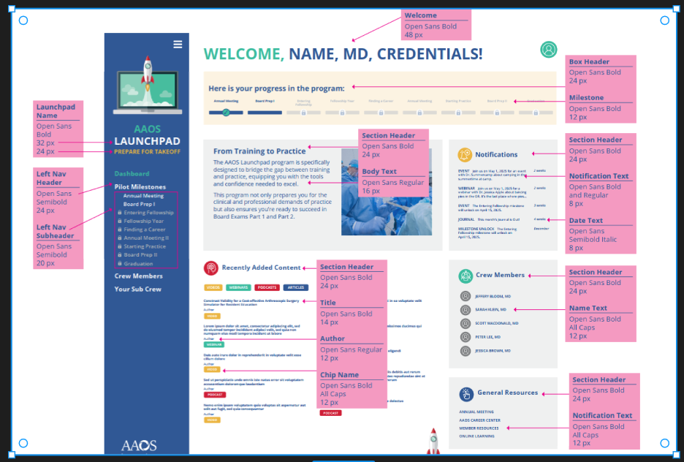

Changes done by Internal Discussion

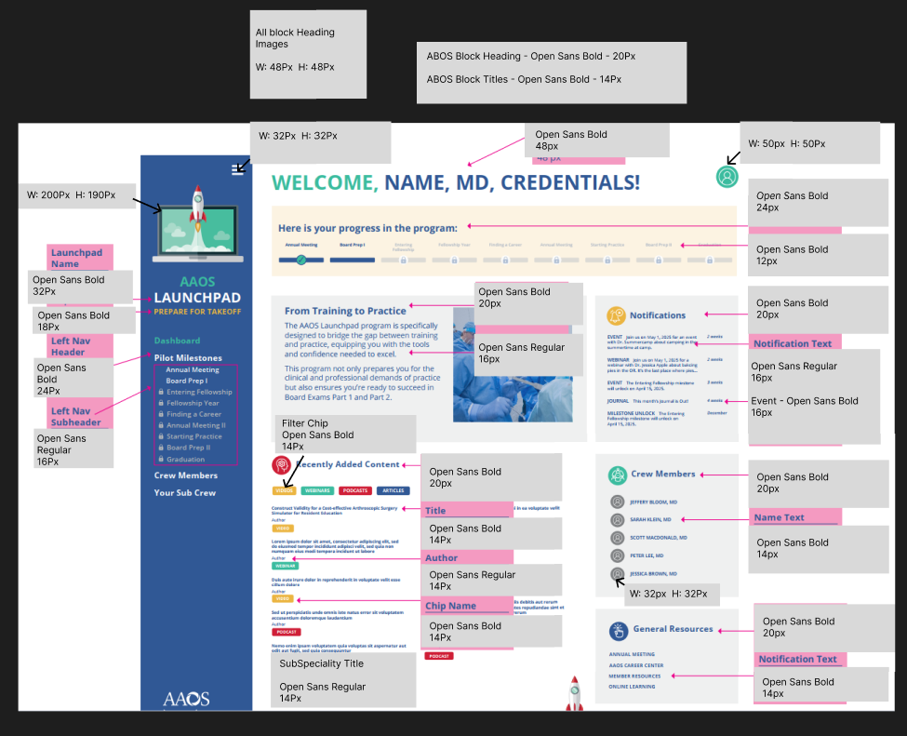

Note: If the Welcome Heading text length is more than 28, the Font Size will be 36px as suggestion from Ravi. Otherwise it will be 48px only.

Crew Members & Sub Crew Members Page Grid Changes

